**Project Write-up**

DESCRIPTION

**Project objective:**

As a developer, write a program to create an arithmetic calculator.

**Background of the problem statement:**

As a developer, write a Java code to create a calculator to perform the four basic arithmetic operations (addition, subtraction, multiplication, and division).

**Validation of an Email ID .**

**package** Arthmatic_Calculator;

**import** java.util.Scanner;

**public** **class** ArthmaticCalculator {

**public** **static** **void** main(String[] args) {

// **TODO** Auto-generated method stub

// double Ans;

Scanner sc=**new** Scanner(System.***in***);

System.***out***.println("eneter the two numbers");

**int** firstnum=sc.nextInt();

**int** secnum= sc.nextInt();

System.***out***.println("Enter the operator ");

**char** op=sc.next().charAt(0);

**double** Ans=0;

**switch**(op){

**case** '+': Ans=firstnum+secnum;

**break**;

**case** '-':Ans=firstnum-secnum;

**break**;

**case** '*': Ans=firstnum*secnum;

**break**;

**case** '/':Ans=firstnum/secnum;

**break**;

}

System.***out***.println("the answer is " +Ans);

}

}

**Output:**

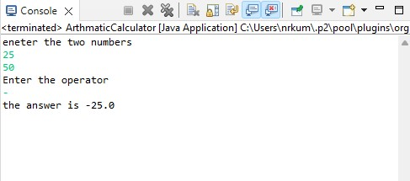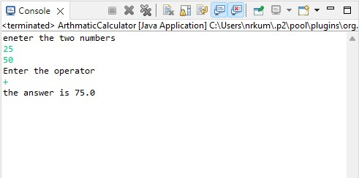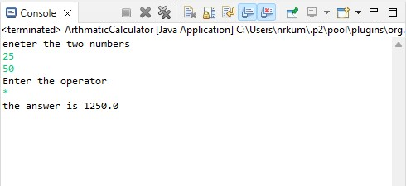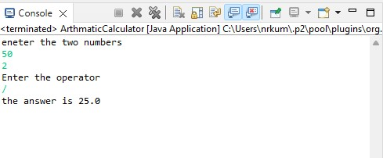

Pushing the code to your GitHub repositories

* Open your command prompt and navigate to the folder where you have created your files.

**cd <folder path>**

* Initialize your repository using the following command:

**git init**

* Add all the files to your git repository using the following command:

**git add .**

* Commit the changes using the following command:

**git commit . -m “Changes have been committed.”**

* Push the files to the folder you initially created using the following command:

**git push -u origin master**